Description | Student Kit A | Student Kit B | Student Kit C
Endurance Ridge 65s Rucksack |  |  | 
Endurance Rucksack Liner |  |  | 
Endurance Dreamlite 300 Sleeping Bag |  |  | 
Endurance Siesta Pro Foam Mat |  | 
Endurance Blaze Headtorch |  |  | 
Endurance Drybag Set |  |  | 
Endurance Survival Bag |  |  | 
Endurance Participant First Aid Kit |  |  | 
Endurance Sleeping Bag Hygiene Liner |  |  | 
Polycarbonate Bowl |  |  | 
Spork |  |  | 
Aluminium Bottle |  |  | 
Highlander Self-Inflating Sleep Mat |  |  | 
Compeed Blister Plasters |  |  | 
RRP (inc. VAT) | £185.00 | £239.00 | £318.00
Your discounted price (inc. VAT) | £102.00 | £138.00 | £198.00
Your Order (please tick one)
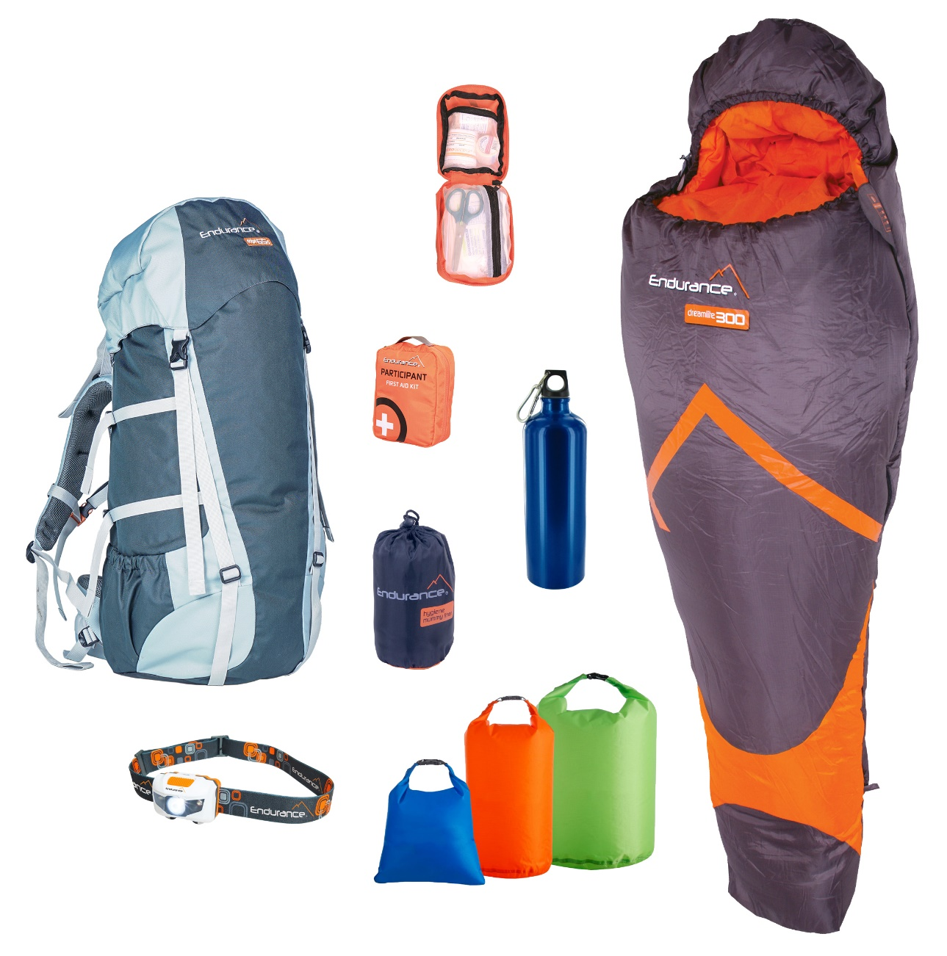
How to order: 1) Fill in your name and class details at the top of this form.
2) Select Kit A, B, or C, by ticking a box at the bottom of the chart.
3) Hand in to Name/DofE Coordinator to order on your behalf.
ORDER DEADLINE Insert date here
Delivery will be made to the school by Insert date here.
Thank you,
Name/School/Position

